Noun Phrase (NP) as Head

🟩 What is Noun Phrase (NP) as Head?
# Source: AI Source: Provided by: [Data Path: Persons Table -> ID Column: 1, Name_En Column: Motasem Essam] -> From: [Chatgpt (GPT‑5 Mini)] on [8/7/2025]
In a noun phrase (NP), the head is always a noun or a pronoun, and it determines the core meaning and grammatical behavior of the entire phrase. The other words (modifiers, determiners, complements) depend on or describe the head noun.

🔹 Types of Heads in Noun Phrases
# Source: AI Source: Provided by: [Data Path: Persons Table -> ID Column: 1, Name_En Column: Motasem Essam] -> From: [Chatgpt (GPT‑5 Mini)] on [8/7/2025]
Here are the common forms that can serve as the head of a noun phrase:
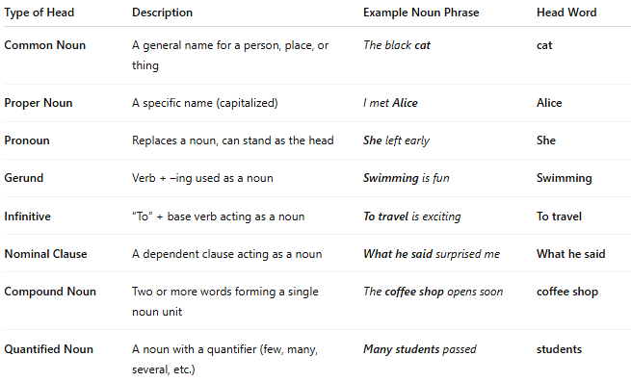
Type of Head | Description | Example Noun Phrase | Head Word
Common Noun | A general name for a person, place, or thing | The black cat | cat
Proper Noun | A specific name (capitalized) | I met Alice | Alice
Pronoun | Replaces a noun, can stand as the head | She left early | She
Gerund | Verb + –ing used as a noun | Swimming is fun | Swimming
Infinitive | “To” + base verb acting as a noun | To travel is exciting | To travel
Nominal Clause | A dependent clause acting as a noun | What he said surprised me | What he said
Compound Noun | Two or more words forming a single noun unit | The coffee shop opens soon | coffee shop
Quantified Noun | A noun with a quantifier (few, many, several, etc.) | Many students passed | students

📝 Notes:
# Source: AI Source: Provided by: [Data Path: Persons Table -> ID Column: 1, Name_En Column: Motasem Essam] -> From: [Chatgpt (GPT‑5 Mini)] on [8/7/2025]
- The head noun controls subject-verb agreement:
The child is playing. vs The children are playing.
- Other words (like determiners, adjectives, prepositional phrases, or relative clauses) may appear around the head but do not function as heads themselves.

